Gerry Su #16325043

EECS 118

Professor Sheu

**Geometry Problem Progress Report 11-22-2018**

To use the problem solver, you need to first create an object of the problem, e.g. problem1(), problem2(), problem3(). There is a CMD interface method I have created called print_menu() that can guide you to use it. Alternatively, can use Problem1.set_value() or set_vertex() to set your desired value. Then you run solve_looping() so it can run calculations to solve all solvable values. Then use get_all() to get a dictionary of the inputs. I will later implement get_all() to be all solved outputs as well on the website, but it’s not necessary for a CMD interface. There is an option in print_menu() that will allow you to retrieve all the solved variables. There is a preset example for each problem as well. To use the preset, select the option from print_menu().

Here is a list of the main functions I Implemented:

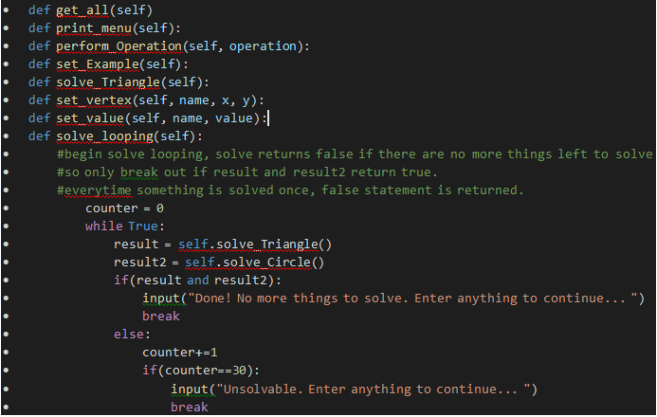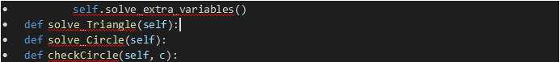

In each problem I use solve_looping(), solving one attribute at a time until all have been solved. A challenge I had that I couldn’t figure out was looping through all the variables in problem 3 because there was a lot. So, I manually checked each value and set cases accordingly. In the video I demonstrate the completeness of the program in all three problems. ☺

Brief Description of the Program:

Video: https://www.youtube.com/watch?v=Ijus3XfBuI0